**APPLICATION LAYER**

**Application Layer Functions**

* Provides **user interface**.
* Provides all facilities we need like **login**, **logout** & **file transfer**.
* Also provides **error handling** & **recovery systems**.

**Protocols Used by Application Layer**

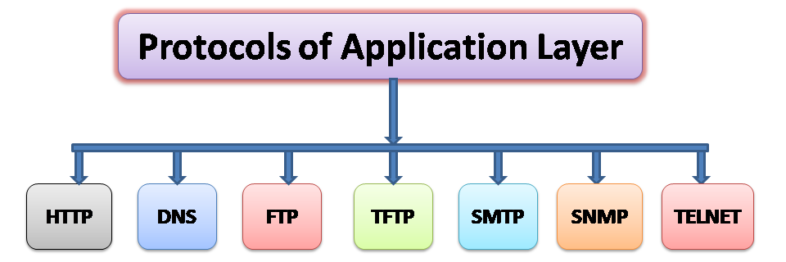

**Distribution of DNS Name Space**

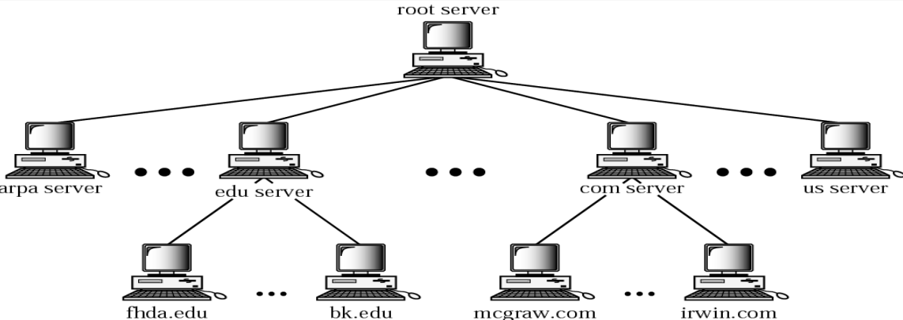

**Zones & Domains**

* **Primary server:** **Main** **storage** place for information on websites.
* **Secondary server:** Serves as a **backup** by replicating information from the **primary server**.
* **Zone transfer:** Transfer of information from **primary** to **secondary server**.

**Types of Domains**

* **Inverse domain:** Converts **domain names** to **IP addresses**, opposite of DNS.
* **Generic domain:** Domains which are **not specific** to any country (***.com***, ***.org***).
* **Country domain:** Domains which are **specific** to countries.

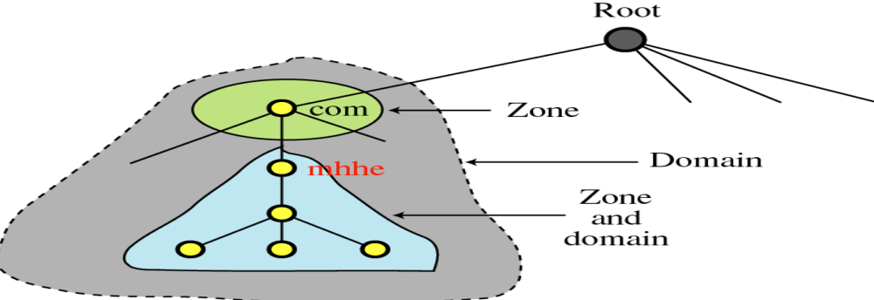

**Dynamic DNS (DDNS)**

* It means automatically updating ***name server*** which stores **names of domains**.
* It can also update **hostname** & **addresses** etc of that domain.
* **IP addresses** changes frequently & are thus **remapped** continuously in **DNS**.
* **DDNS** is used when an internet user **can’t** afford **static IP** address.

**Telnet**

* ***Telnet*** is a client-server **application program**.
* Provides an **abstraction** over the computing going on in **terminal**.
* Also, its **speed** gives an **illusion** to users of working directly with the internet.

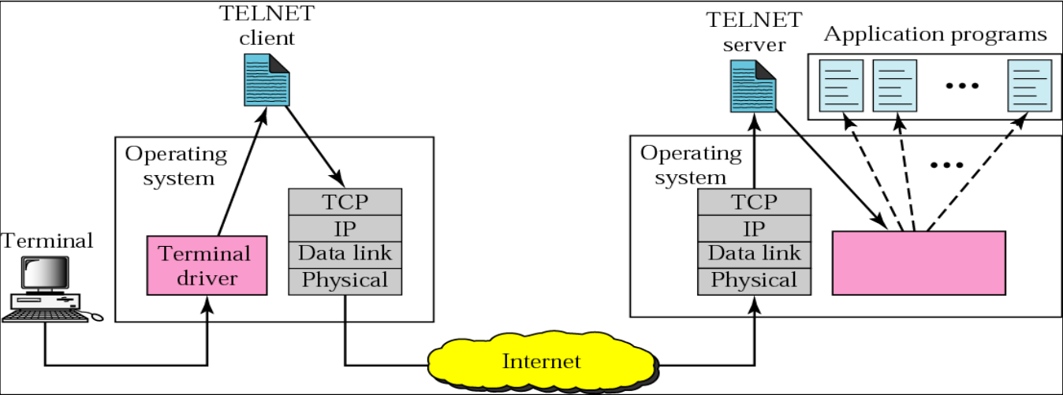

**Electronic Mail**

* Known as **E-mail** in short.
* **Asynchronous** form of communication.
* It got many modern features, from **hyperlinks** to adding **attachments**.
* Uses **SMTP** protocol.

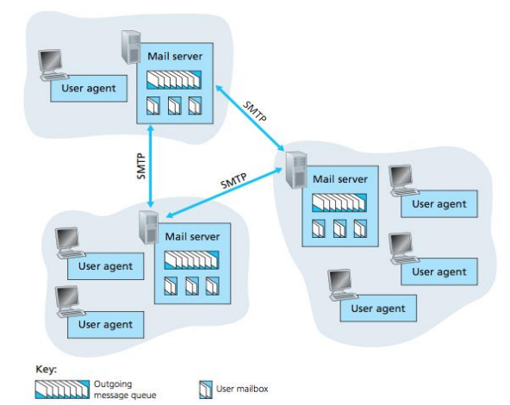

**SMTP**

* Enables sender to receiver **mail transfer** (server to server).
* Restricts mail’s **body** (**not** header) for being upto **7-bit ASCII code** (each character used in the body).
* If receiving server is **down**, then mail attempts to get transferred & waits at **sender’s server** until the **receiver server** is back to work.
* And **SMTP** is called by **TCP** when it notices that the nature of data is **mail**.

**Mail Transfer Phases**

* **Phase 1:** Connection between **MTA client** & **MTA server** is established.
* **Phase 2:** Message is **transferred**.
* **Phase 3:** Connection is **terminated**.

**UAs & MTAs**

* **MTA:** Mail transfer agent
* Two users can communicate through **SMTP client** & **SMTP server** via internet.
* But user’s message has to pass through **UA** to reach **MTA** at sender’s side & pass through **MTA** to reach **UA** at receiver’s size.

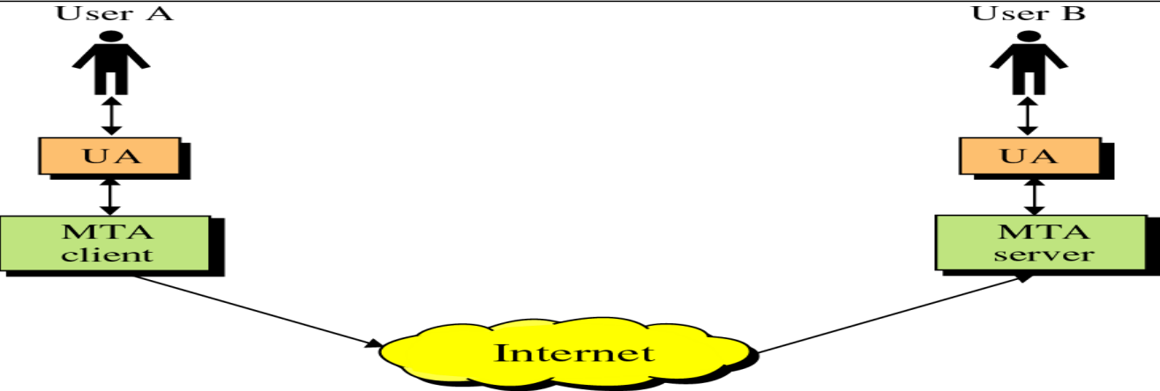

* **Relay MTA:** The MTAs coming **between** MTA client & MTA server.
* **Email gateway:** A system **supporting** **transfer** of message through variety of systems.

**Email Address**

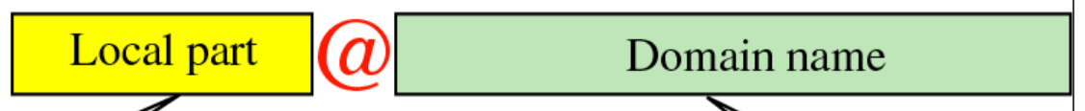

* **Local part:** Address to find in the mailbox.

**Mail Address Protocols: POP3**

* **POP3** stands for **post office protocol**.
* **POP3** can act when the sender is **connected to TCP** successfully.
* Server acts as a **buffer** **intermediate** between **sender** & **receiver**.
* Job of **POP3** is to **delete message** from server after **receiver** receives it.

POP3 phases:-

* **Phase 1:** The **username** & **password** provided by sender are **verified**.
* **Phase 2: Receiver** **receives** the message by sender.
* **Phase 3:** **POP3’s** session ends & message is **deleted** from server.

**Mail Address Protocols: IMAP**

* **IMAP:** Internet message access protocol
* Best example for **IMAP** is **Gmail**.
* By **default**, the messages sent are stored in **inbox** folder at the server.
* With use of **IMAP**, user gets the ability to **move a mail** from one folder to another.
* For example, we can store a particular mail in **starred** folder.
* Also, we can **search** messages by their **properties** in **search bar** due to this.

**File Transfer Protocol (FTP)**

* **FTP** requires two **TCP** connections to work.
* Uses ***port 21*** for **control connection** & ***port 20*** for **data connection**.

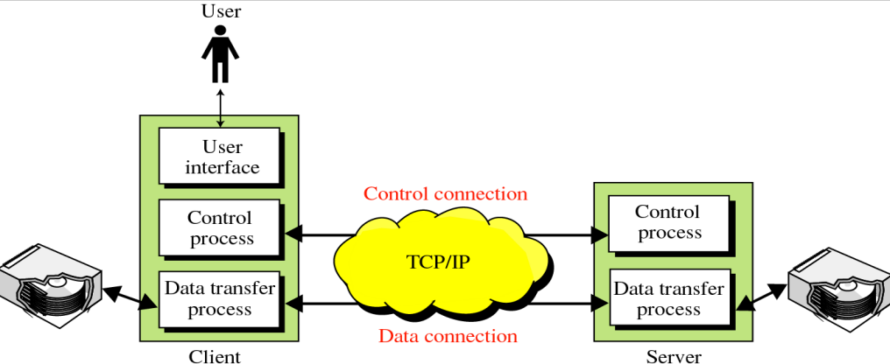

* **FTP** enables reliable **transfer of data** from client to server.

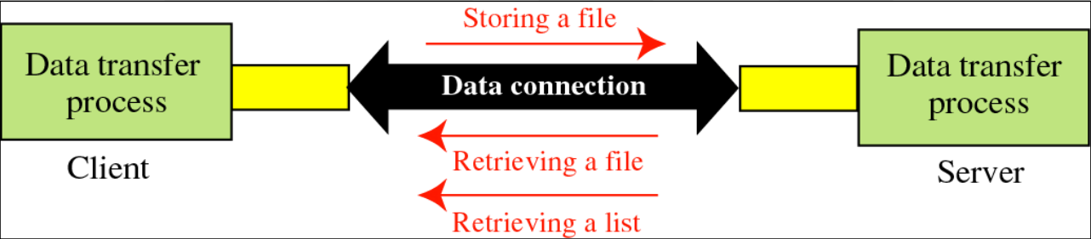

**World Wide Web**

* Used to **uniquely identify** each **URLs** as part of same information family.
* **Web pages** are made from **base HTML file** with various other **referenced objects**.
* These **reference objects** can be **image file**, **audio file** & **applet** etc.
* **Applet:** Applets are **plug-ins** & are generally written in **Java**.
* **Plug-in:** Small program that performs some tasks in a **large** program.
* And each of these **objects** are addressed uniquely by **URL**.
* **URL:** Uniform resource locator

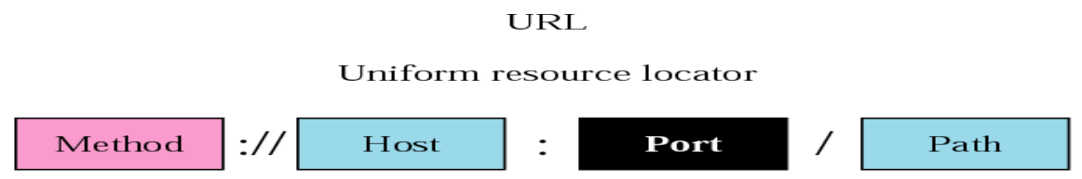

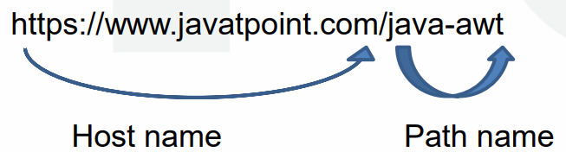

**Types of Web Documents**

* **Static document:** Document is **stored** in web server & delivered when user requests its access.
* **Dynamic document:** Document’s **program is stored** in server & that program is executed when a user requests its access.
* **Active document:** Documents that are **executed locally** on server; because their properties **may change**. For example, **animations**.

**Hyper Text Transfer Protocol (HTTP)**

* Uses **TCP** on ***port 80*** (client initiates it).
* **HTTP** is implemented on **both** client & server programs.
* Defines **structure** of messages & also defines how clients and servers **communicate**.
* **Servers** can also **reject** requests made by **client**.
* HTTP **doesn’t** store any client information.

Types of HTTP connections:-

* Non-persistent HTTP
* Persistent HTTP

**Simple Network Management Protocol (SNMP)**

* Manages **internet devices** like routers, modem etc.
* Allows a manager to **monitor** these devices.
* **Agent:** **Managers** who send request to **network devices**.
* **Network management system (NMS):** Enables running applications which are used in monitoring network devices.
* The **agent** and other **managers** communicate using **TCP/IP**.

**Firewall**

* A **threat protection system** between computers or groups of computers.
* It filters out potential threats that are visible.
* Used when one network tries accessing another.
* For example, **LAN** accessing data from **WAN** or a **LAN** tries accessing **another LAN**.
* ***Firewall*** can be a **hardware**, **software** or **combination** of both.

**Hardware Firewall**

* ***Firewall*** is connected between a ***modem*** & **computer**.
* **Modem:** Modulator-demodulator
* Also used with **broadband** ***routers*** to secure its connections.
* **Expensive** & **hard to configure**.
* **Configure:** Setup/install
* **Ex:** Cisco Pix & Netscreen etc.

**Software Firewall**

* Can protect **only single** computer.
* Need to be installed in individual computers for protecting all.
* Are **cheaper**.
* **Ex:** Norton Internet Security & McAfee Internet Security etc.

**Bluetooth**

* Are **short-ranged** & **secured**.
* Uses a radio technology called ***frequency-hopping spread technology***.
* Data transfer rate is around **1 Mbps**.
* Developed & licensed by **Bluetooth SIG**.
* **Bluetooth SIG:** Bluetooth special interest group.
* Easy configuration.
* Low power consumption.
* **Cheaper** prices.
* Supports ***Ad hoc*** networking.
* **Ad hoc:** Connectable to another device in range which is using **same network type**.

**Piconet**

* It is when multiple ***Bluetooth* devices** are sharing common network channel.
* Known as **basic unit** of ***Bluetooth* networking**.
* Uses **3-bit addressing** method.
* Devices are **synchronized** to connect & communicate.
* There can be **upto eight devices** connected with one of them being **master** & rest being **slaves**.
* Collision between multiple **piconets** is possible.

**Scatternet**

* Connection of **two piconets**.
* Device in one piconet may be treated as **slave** or **master** in another piconet, depending on the situation.
* Utilizes **bandwidth** in a complete manner.

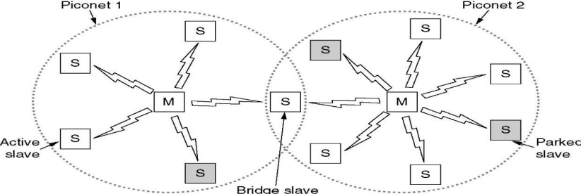

**Bluetooth Layers**

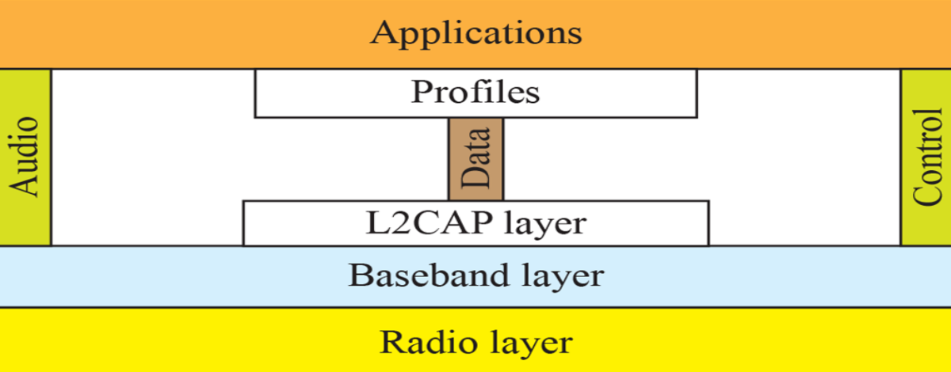

* **Radio frontend (RF):** Is receiver’s **radio wave sensitivity** level & arranges **channels**.
* **Logical link control & adaptation protocol (L2CAP):** Used for transferring large data files to upper layers.
* **Service discovery protocol (SDP):** Used by a ***Bluetooth* device** to access resource or use facility of another ***Bluetooth* device**.
* **Link manager protocol (LMP):** Handles ***piconet*** & **security** configuration.
* **Radio frequency communication (RFCOMM):** Used for transferring data from higher level to lower level.
* **Object exchange protocol (OBEX):** Used for sharing data among ***Bluetooth* devices**.

**Cryptography**

* ***Cryptography*** is **conversion** of text into unreadable form.
* We call the **original text** as ***plaintext*** & its **encrypted form** as ***cipher text***.
* It is even used for **protecting** communication data.

Objectives of cryptography:-

* Integrity
* Authentication

***\*And all synonyms of authentication like confidentiality etc…\****